Navigation Tips for the CSL Resource
Communicating Student Learning Resource and Professional Development Tool

Tips to navigate the Book using a laptop:

The Navigation Bar

Top Left: On the top left section of the navigation bar you will see

- Far left symbol (book) - takes you to your Apple Book Library
- Middle symbol - takes you to the Table of Contents
- Far right symbol - takes you to “Show Notes on your Study Card”- where you will see a left margin with a list of any study notes that you have added. Notes can be added and/or sections of texts highlighted by following these steps:

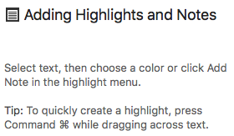

Top Right: On the far right of the top navigation bar you will see

- Far left symbol (magnifying glass) - allows you to search a word in the Book to see how many times it is referenced, the page and the surrounding text. For example, if you typed in the word “formative” in the search box you will see that it is mentioned 50 times in the Book, including in the glossary. See some of results from this sample search below:
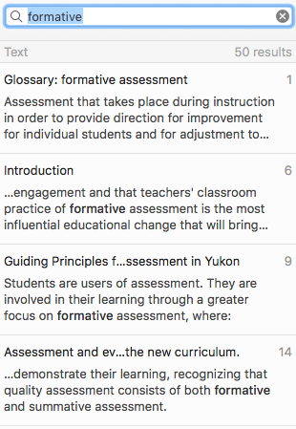

- Middle symbol (bookmark) - if you find a page that you want to go back to easily and often, you may wish to bookmark the page. The bookmark symbol then turns red.

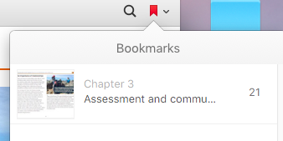

- Far right symbol (downwards arrow) - provides a list of all the pages you have bookmarked

Turning Pages

To turn pages on your laptop simply swipe your tracking pad OR hold your finger over the right middle side of the page and a grey arrow symbol pops up (see below) that will also change the pages

Other ways to scroll through the Book

Under the View dropdown menu, you will notice ‘Show Thumbnails” which presents all pages of the Book at the bottom of your screen, allowing you the option to simply swipe through the pages to the one you are looking for.

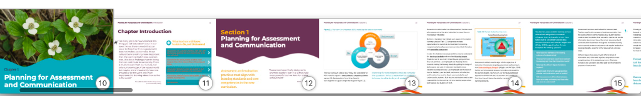
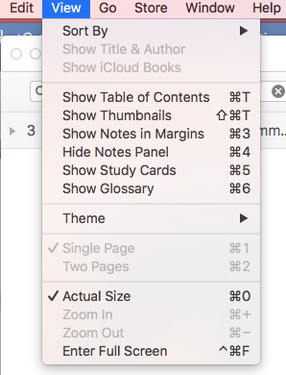

Other Symbols

The first two symbols you may come across are the Parent and Child symbol and the Wolf and Crow symbol. Click on the symbol to view the pop-up describing what the symbol means. See below.
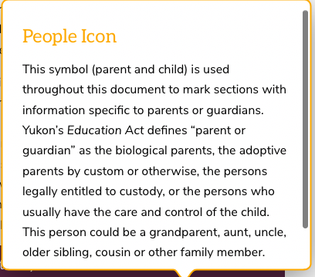
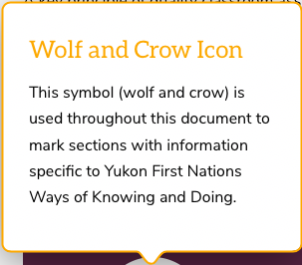
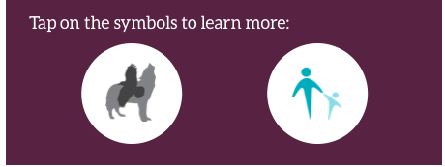

Turquoise circle with a white plus symbol - click on the symbol to view further explanations and examples.

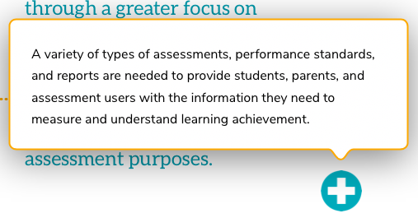

Other similar symbols will take you to:

- Links & Resources - useful resources and websites

Glossary and Definitions

Highlighted/underlined word – click to bring up a definition, a link to the Book glossary and a link to a dictionary.
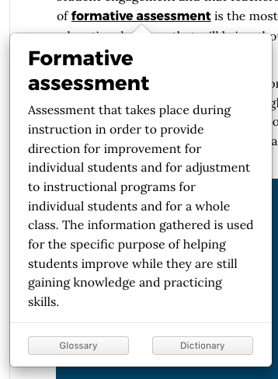

Blue/underlined texts - direct link to a website, such as the example below which takes you to BC’s New Curriculum page

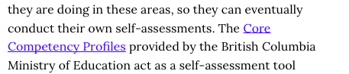

Viewing pdf documents in the Appendix

When viewing a pdf document such as the samples in the appendices you may get a pop-up beginning with ‘Whoops!” like the one below. To see these in full screen view first choose to “Share this PDF document” by emailing it to yourself. This is only when using a laptop.

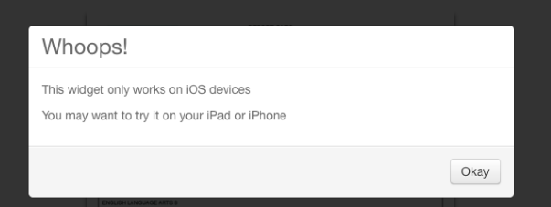
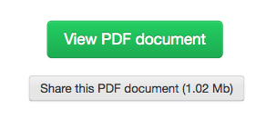

Tips to navigate the Book using an iPad:

There are only a few differences when using an iPad to view the Book.

Top Navigation Bar

To view the top navigation bar, tap the top of the page.

Top Left:
- Far left symbol (arrow) - closes the Book
- Middle symbol (periods with lines) - takes you to either the Table of Contents, or the Glossary Page. Clicking on one brings up mini-pages of the Book on the bottom of the screen, then just swipe to get to the page you want.
- Far right symbol (pages) - takes you to the Table of Contents where all chapters are listed

Top Right:
- Far left symbol (star) - allows you to adjust the brightness of the screen
- Middle symbol (magnifying glass) - allows you to search words (similar to laptop function)
- Far right symbol (flag) - allows you to bookmark pages (similar to laptop function)

Changing Pages

You can either swipe your screen or tap on the arrows on the bottom left and right side of each page.

