ART CONTINUUM OF BIG IDEAS (UNDERSTANDING)
 | K | 1 | 2 | 3 | 4 | 5 | 6 | 7 | 8 | 9
We Express  Ourselves with Art | People create art to express who they are as individuals and community. |  | Creative expression develops our unique identity and voice. | The mind and body work together when creating works of art. | Creative expression is a means to explore and share one’s identity within a community. | Engaging in creative expression and experiences expands people’s sense of identity and belonging. | Engaging in creative expression and experiences expands people’s sense of identity and community. | Through art making, one’s sense of identity and community continually evolves. | Creative growth requires patience, readiness to take risks, and willingness to try new approaches. | Identity is explored, expressed, and impacted through arts experiences.
We Inquire and  Learn with Art | Engagement in the arts creates opportunities for inquiry through purposeful play. |  | Inquiry through the arts creates opportunities for risk taking. | Creative experiences involve an interplay between exploration, inquiry, and purposeful choice. | Artists experiment in a variety of ways to discover new possibilities. | Artists experiment in a variety of ways to discover new possibilities and perspectives. | Artistic expressions differ across time and place. | Experiencing art challenges our point of view and expands our understanding of others. | Individual and collective expression can be achieved through the arts. | The arts provide opportunities to gain insight into the perspectives and experiences of people from a variety of times, places, and cultures.
We Communicate with Art | Dance, drama, music, and visual arts express meaning in unique ways. |  | Dance, drama, music, and visual arts are each unique languages for creating and communicating. |  |  |  |  |  |  | Dance, drama, music, and visual arts use their own unique sensory language for creating and communicating.
Art Connects Us | People connect to others and share ideas through the arts. |  | People connect to the hearts and minds of others in a variety of places and times through the arts. | The arts connect our experiences to the experiences of others. | Exploring works of art exposes us to diverse values, knowledge, and perspectives. | Works of art influence and are influenced by the world around us. | Experiencing art is a means to develop empathy for others’ perspectives and experiences. | Engaging in the arts develops people’s ability to understand and express complex ideas. | Artists often challenge the status quo and open us to new perspectives and experiences. | Creative arts experiences can build community and nurture relationships with others.
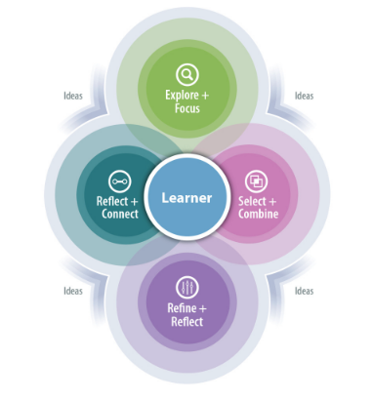
These Big Ideas can be explored through dance, drama, visual art and music
Creative Processes include: explore and focus, select and combine, refine and reflect, and reflect and connect

