Communicating Student Learning
Using FreshGrade for Digital Portfolios

Each portfolio post should include the elements found on the outside of the image below:

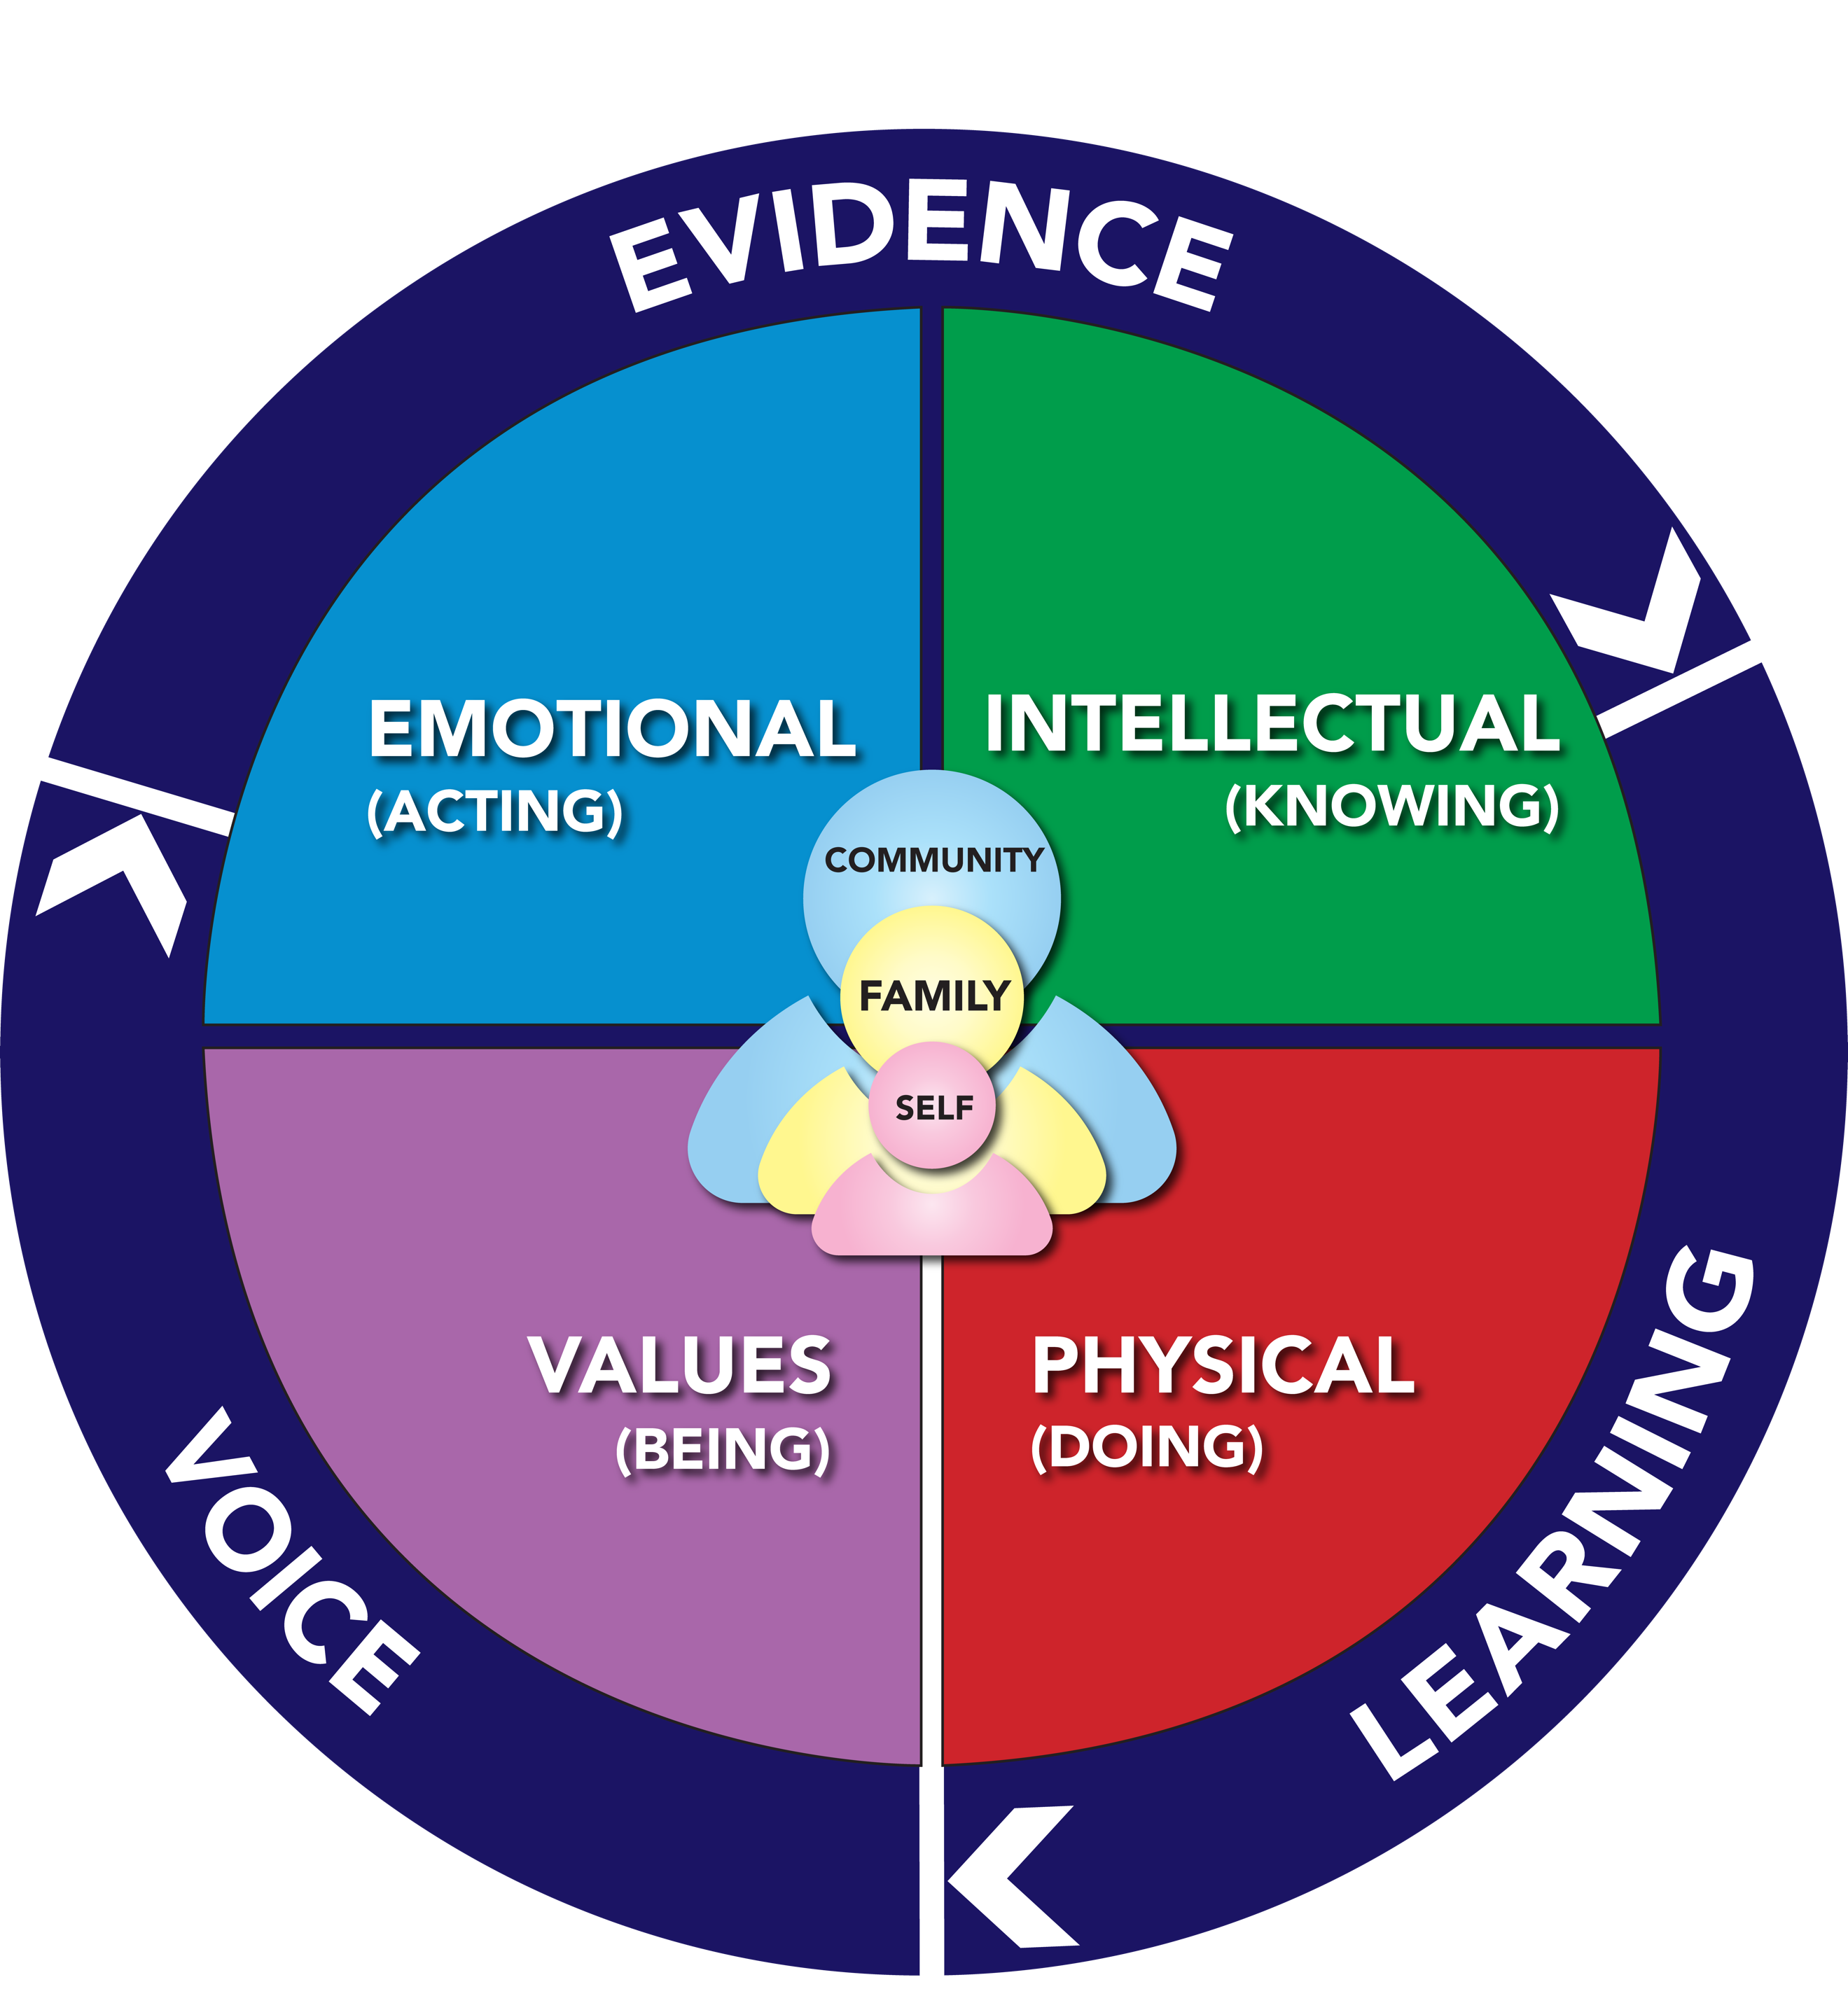

EVIDENCE: Evidence of what the learner knows, what they can do, and/or what they understand. This includes photos, videos or documents.

LEARNING: Meaningful descriptions of the learning task, learning standards or an assessment of student progress gives evidence of learning. Over time, this evidence will demonstrate growth and shift learning to shared ownership.

VOICE: With the inclusion of student and parent voices, ownership of learning shifts from teacher focused to shared ownership by students, parents and teachers.

