Name: ___________________________
Let’s what I can do in group work sessions!
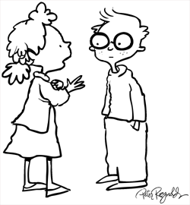  Tell someone something | 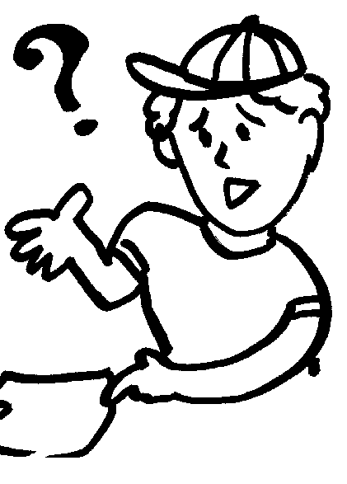  Ask a question
Answer a question | 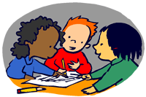  Help others to get work done
Circle and Draw!
1.
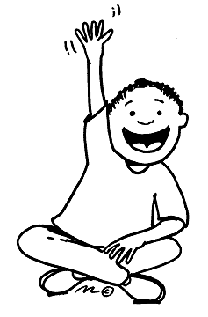
2.
Tell someone something | Ask a question
Answer a question | Help others to get work done
3.
Tell someone something | Ask a question
Answer a question | Help others to get work done
I’m really good at:
I’d like to get better at:
Teacher Signature

