Name: _________________________ Division ______
Ask simple questions
Answer questions
Disagree respectfully
Share information about a topic
Present information in a clear and organized way
Help my group meet a goal
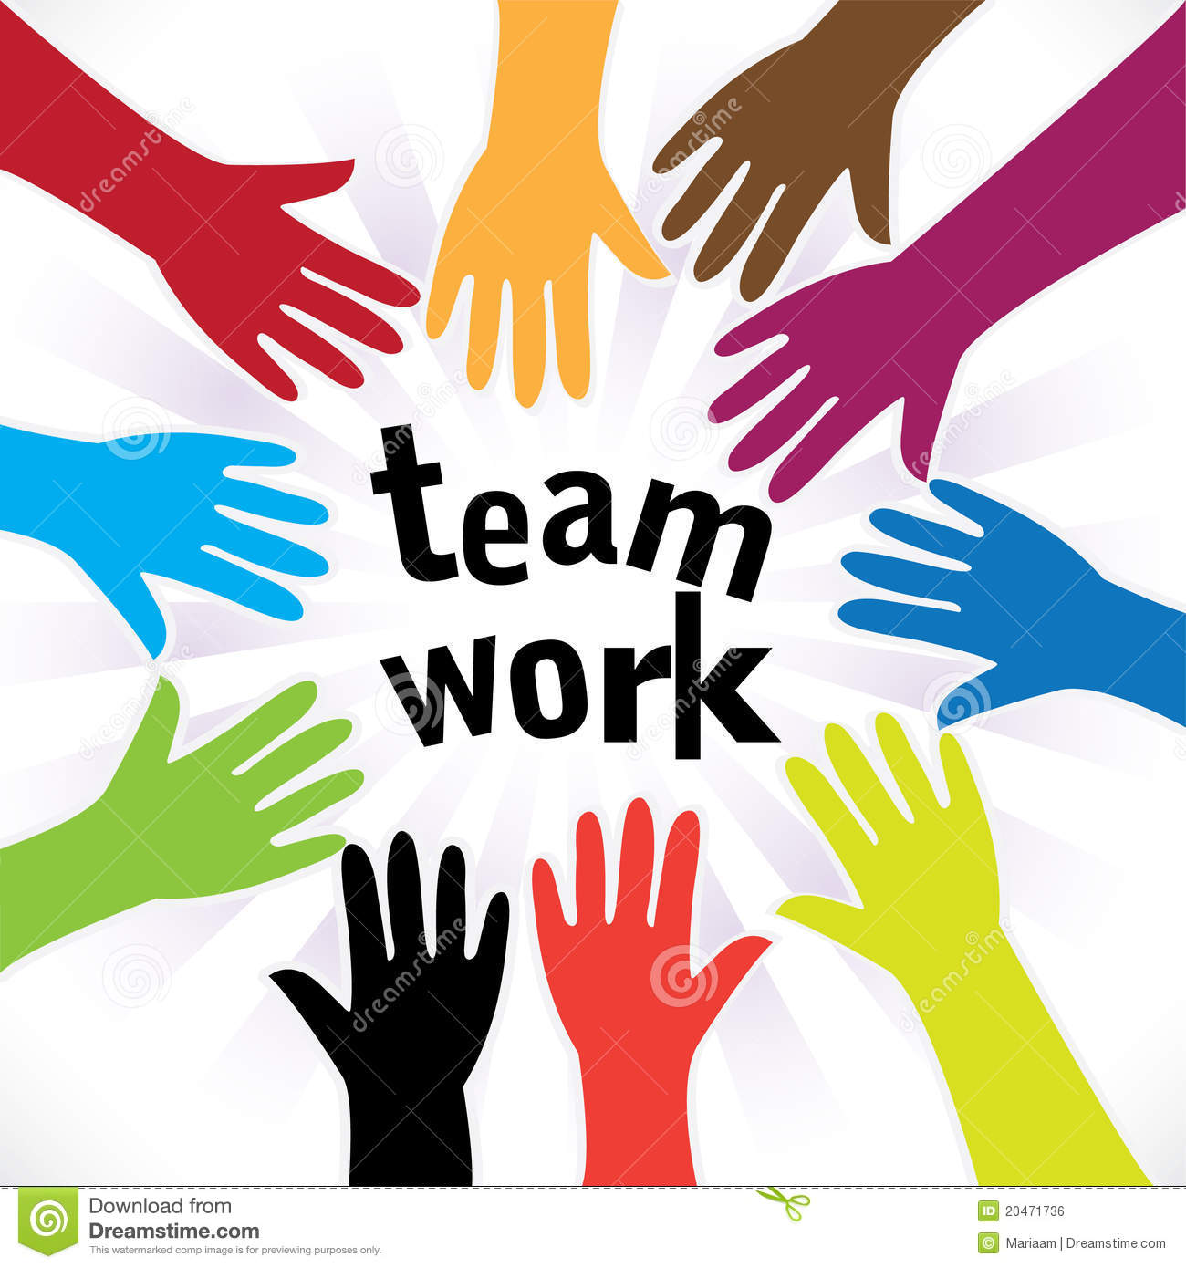
Take on a role or responsibility
Find things my group agrees on
Give feedback to someone

Let’sWhat I can do in group work sessions!
Sketch Write
1
Next time, I’ll try

________________________________________________________________________________________________________________________________________________________________________

________________________________________________________________________________________________________________________________________________________________________
Next time, I’ll try

2

Next time, I’ll try

________________________________________________________________________________________________________________________________________________________________________
3

As a group member, I am really good at: __________________________________________________________

I’d like to get even better at:

_____________________________________________________________________________________

