Educator Update
Yukon Department of Education
Learning Branch
November 2017
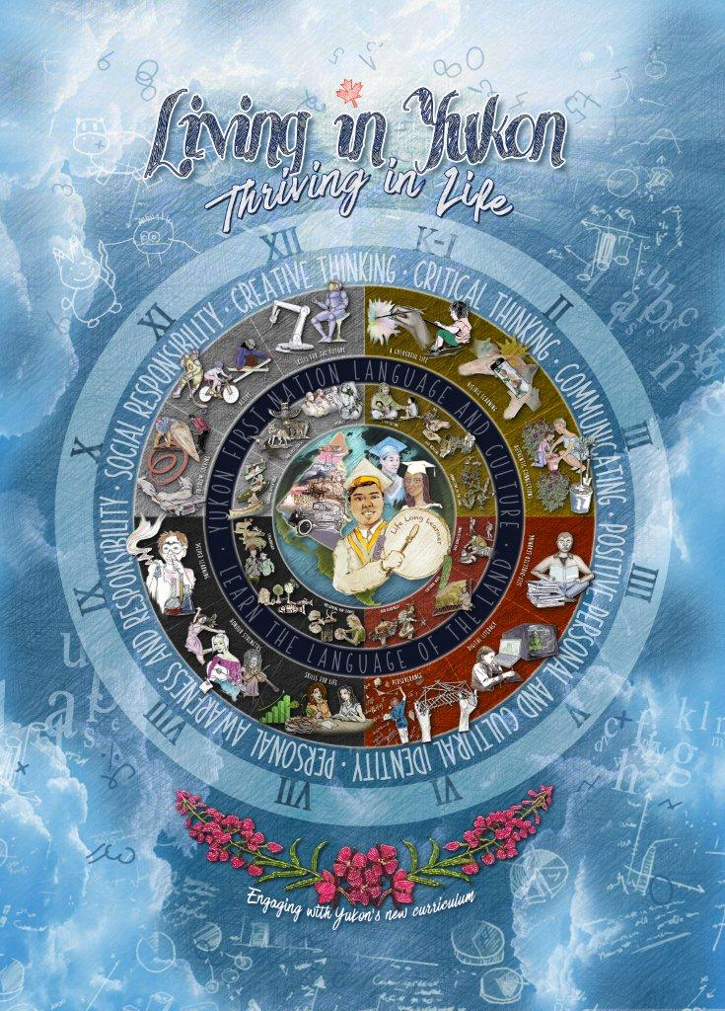

Contents
Curriculum art work 2
K-12 Assessment Guidelines 2
Online sessions on the Communicating Student Learning iBook 2
K-9 Curriculum 3
Welcome to new Learning Branch staff 3
Professional learning (PD days) 3
10-12 Implementation Update 3
B.C. Numeracy & Literacy Assessments 3
Opportunity: Learning Networks 4
One-to-one Cost Sharing Program 4
Coming soon: video series on curriculum and assessment 4
Where to get more information 4

Curriculum art work

The cover of this month’s Educator Update is a new piece of art and visual communication tool to help us illustrate the changes in the curriculum, which the Minister of Education unveiled on November 7 at Elijah Smith Elementary.

Over the next two weeks, each school will receive one printed copy on a hanging banner as well as glossy posters. French copies are also available. Schools with more than 200 students will receive four poster copies to hang in the school and smaller schools will receive two copies. You can order additional poster copies through Resource Services upon request using your school’s CMCA budget.

This art represents all that we heard last year from teachers, students, parents and community members about the curriculum. You can view the artwork and a full description of the project here.

K-12 Assessment Guidelines

The Communicating Student Learning iBook and updated Assessment Alignment Chart are available for download and are essential tools to support teachers in the assessment changes this year. Check out page 81 of the iBook for ideas on what to include in a written informal report.

A reminder that letter grades are no longer being used for K-9. Checklists of requirements for assessment for K-9 and 10-12 are online and were distributed in the October Educator Update.

Schools have now confirmed whether they are following Option 1 or 2 from the Interim Guide on Student Assessment. Check with your principal for more information.

The schools trying Option 1 this year include: Grey Mountain, Hidden Valley, Jack Hulland, Kluane Lake, Nelnah Bessie John, Takhini, Teslin, Watson Lake Secondary, and Whitehorse Elementary. All other schools are following Option 2.

Online sessions on the Communicating Student Learning iBook

On Wednesdays from 3:30-4:30 p.m., Curriculum and TAL are hosting online information sessions for questions about the Communicating Student Learning iBook and how the changes apply to classroom practice and reporting at your school.

The sessions run every Wednesday from November 15 to November 29. The online meeting room is at: https://zoom.us/j/757615973. Please ensure you have a quiet space with headphones.

For more information or to send questions ahead of time please email Nikki Krocker at nikki.krocker@gov.yk.ca.

K-9 Curriculum

Curriculum resources and instructional samples are available here:
- Learning Branch Website: Other Assessment Resources, Planning Tools, FNPP website, and Yukon First Nation Resources for Teachers Handbook
- B.C.’s website
- ERAC
- BCTF

If you have a great lesson or unit to share, please email curriculum@gov.yk.ca

Welcome to new Learning Branch staff

Please join us in welcoming a few new staff members, who can also provide you support:

- Debbie Gohl, Curriculum Consultant until January 2, 2018 - debbie.gohl@gov.yk.ca
- Betty Burns, Primary Curriculum Consultant, started on October 23, 2017 -betty.burns@gov.yk.ca
- Tanya Lewis, Secondary Curriculum Consultant, beginning January 2, 2018
- Flora Asp, First Nations Curriculum Consultant, beginning December 2017
- Patti Grabowski, Library Systems Technician, auxiliary on call - patti.grabowski@yesnet.yk.ca

Professional learning (PD days)

Curious about what other schools are doing on their curriculum training days? Topics in October and November include:

- Embedding the Assessment of Core Competencies into Classroom Instruction
- Documenting Learning Experiences with Portfolios
- Communicating Student Learning: Informal Reporting
- Communicating Student Learning: Formal Reporting
- Instructional Design: Integration of YFN Ways of Knowing and Doing into Cross-Curricular Units
- Using Yukon Education Supported Apps as Assessment Tools
- Connecting New Curriculum Resources to Meaningful Professional Learning
- Digital Portfolios using Fresh Grade

10-12 Implementation Update

B.C recently announced changes to the implementation timeline for the 10-12 curriculum to make sure that teachers, administrators, post-secondary institutions, students and parents are fully prepared. The draft Grade 10-12 curriculum is now in the process of being revised and improved and will be finalized by the summer of 2018.

The Department of Education is reviewing these changes and discussing how this will affect Yukon’s 10-12 curriculum implementation timeline. An update on this will be coming soon.

In B.C., the new timeline will look like this:

Grade 10: the curriculum will be introduced during the 2018/19 school year as planned. The Grade 10 curriculum documents will be finalized and available for use in April 2018.

Grade 11 and 12: the curriculum will be introduced in the 2019/20 school year, a one-year delay. The courses for these grades will receive one year of transition support and be finalized and available online June 30, 2018.

B.C. Numeracy & Literacy Assessments

Numeracy assessment on schedule: this assessment will be available to Yukon students in grades 10-11 starting in June 2018. Only a subset of B.C. students will write it in January 2018 as part of a managed implementation. Sample assessments for practice are available online, as are assessment design specifications.

Literacy assessment delayed one year: B.C. has also delayed the new literacy assessment. It is now expected to be available in January 2020. We will provide a further update on this soon.

Here is the most current information about the transition between the old and new graduation programs.

More graduation assessments questions and answers are available online.

If you have any questions, please contact Paula Thompson at paula.thompson@gov.yk.ca

Opportunity: Learning Networks

In spring and summer 2018, up to six Yukon teachers from our learning networks may attend the May Network of Innovation and Inquiry (NOII) Symposium in Richmond, BC or the July University of British Columbia (UBC) Summer Institute: Inquiry and Innovation for School and System Leaders.

If you already have an inquiry group in place, submit your inquiry group description and collaboration schedule to paula.thompson@gov.yk.ca by November 17 to be considered for these learning opportunities in B.C. this spring and summer.
For a schedule of upcoming Learning Network opportunities and more information about Learning Networks and how you can get involved, check on the Learning Networks page.

One-to-one Cost Sharing Program

Registration for wave 6 of the One-to-One Mobile Technology Cost Share Program has begun. The intake for wave 6 will close mid-December and equipment pick is expected in the 1st week of January 2018.

Sign up here: https://kb.yesnet.yk.ca/1to1-signup/

More information can be found here: https://kb.yesnet.yk.ca/teacher-one-to-one-cost-share/

Coming soon: video series on curriculum and assessment

This school year, we will be producing a video series to help students and parents understand the changes to curriculum and assessment.

Later in November, we will release the first video, which focuses on the new performance report card for students in Grades 4-9.

Our next video will give an overview of what the curriculum will look like in classrooms.

The final video will explore how schools integrate Yukon First Nations ways of knowing and doing.

These videos will be shared on online and we encourage you to share them with parents as they become available. More information coming soon.

A special thank you to the staff, students and schools who have participated in these videos so far! We’re excited to share the first video soon.

Where to get more information

Monthly Educator Updates in your inbox, which summarize the current directions and information about the curriculum and assessment changes.

The Learning Branch website, to find current information and resources to support your professional learning and practice.

Talk to your Principal or ask the Learning Branch team at curriculum@gov.yk.ca.

Send any questions: edu1to1@gov.yk.ca

