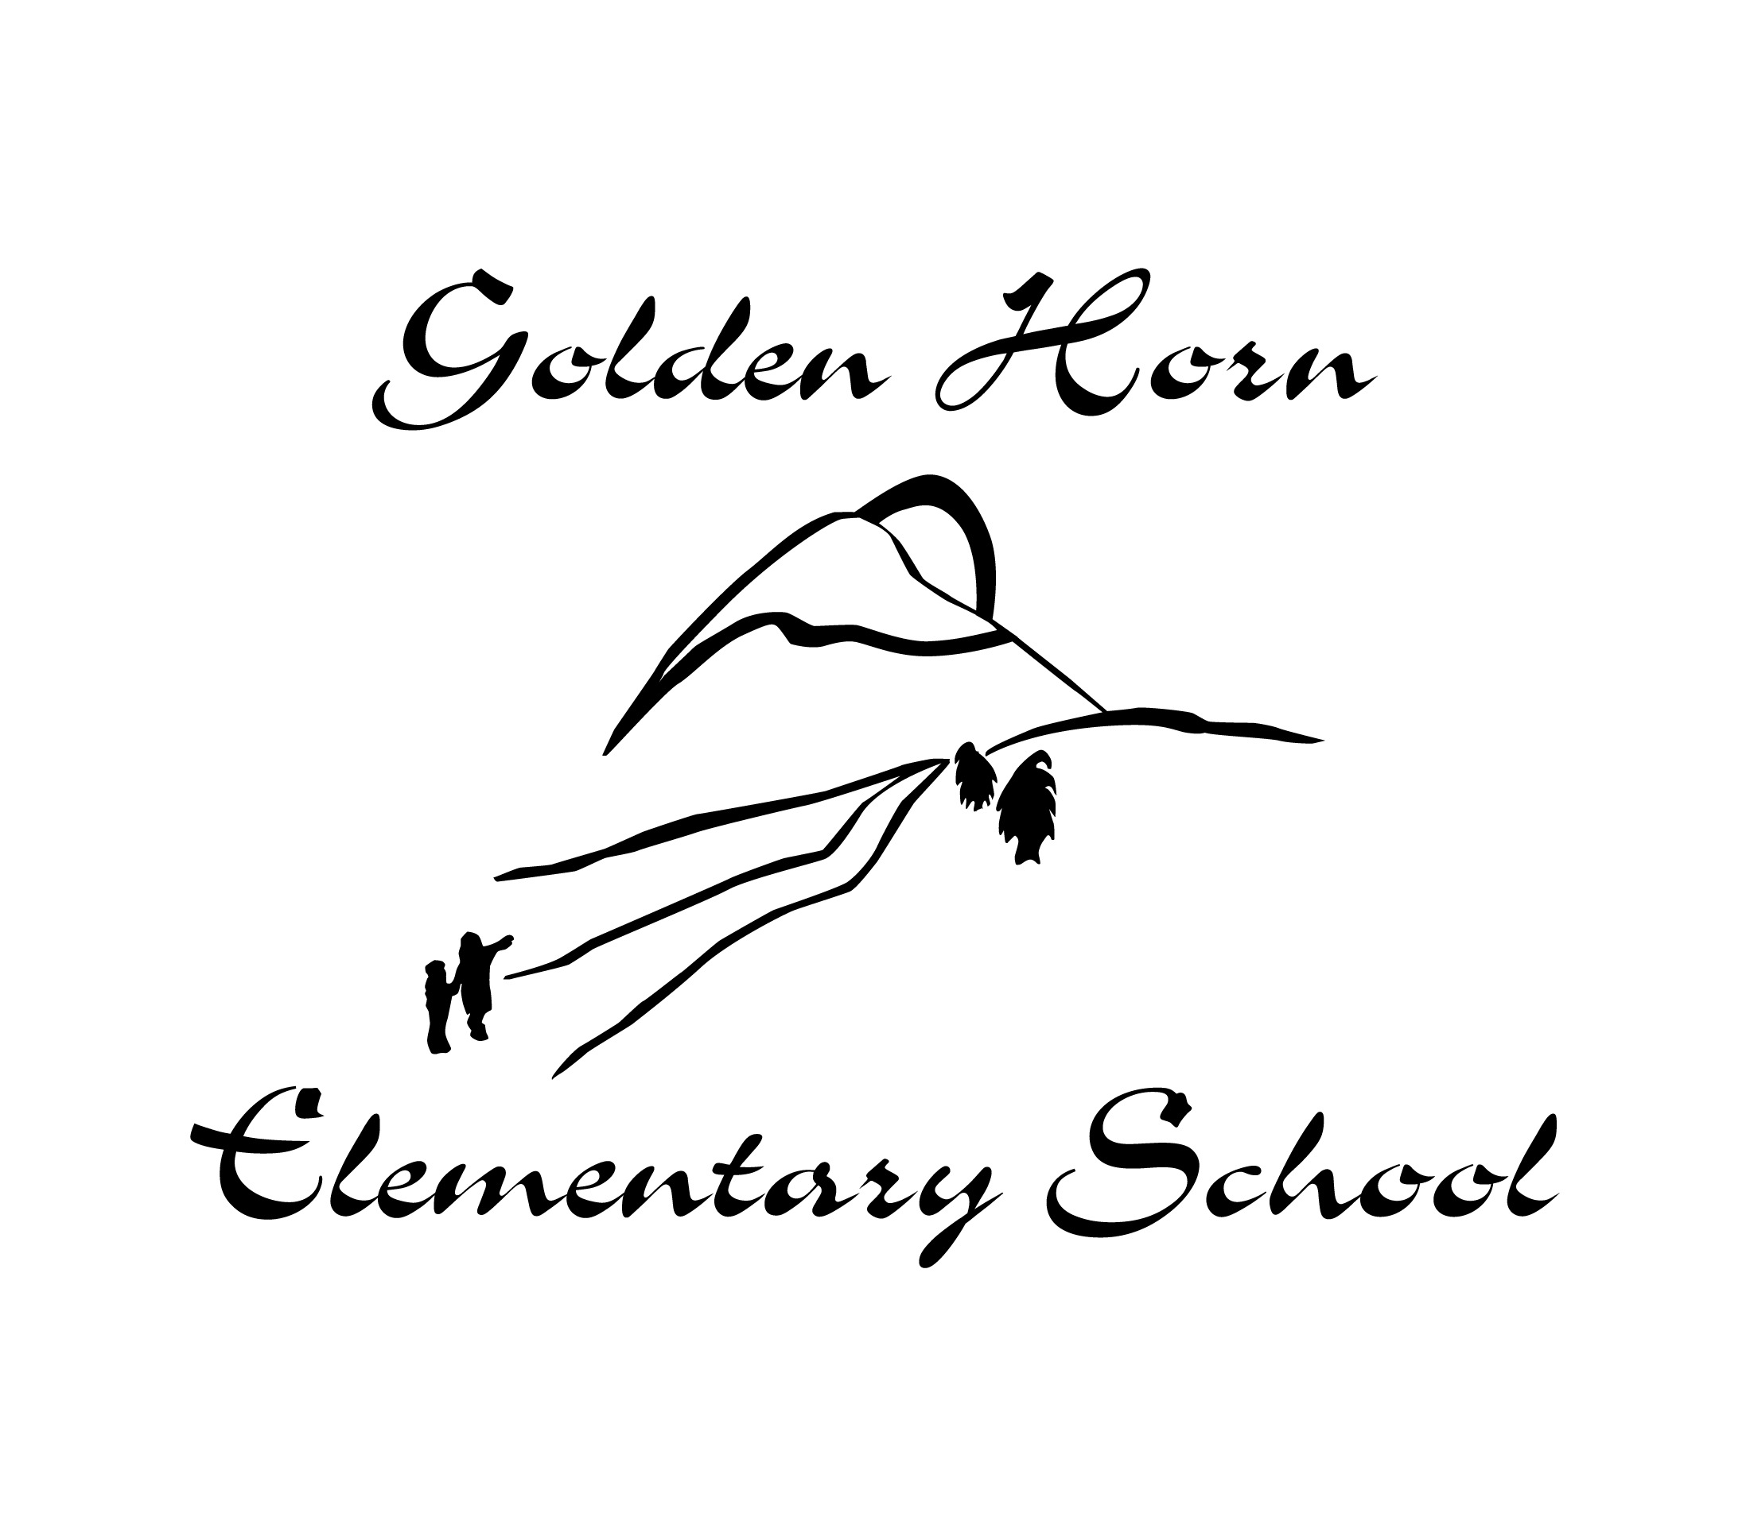
Student Interim Report 2018-2019
Golden Horn Elementary School
Duncan Drive, Whitehorse, Yukon Y1A 7A1 • 867-667-8130
Principal: Darcy LeBlanc Vice-Principal: Jesse Ward
We respectfully acknowledge that we teach and learn within the traditional territories of Kwanlin Dun First Nation, the Ta'an Kwachan Council and Carcross Tagish First Nation.
Student Name:
Grade: | Teacher:
Attendance Data for August 21- November 30, 2018:
#NAME was absent # days and was late # times.

This assessment describes the student’s learning progress based on expectations for this time of the year.

NY: Not Yet Meeting Expectations
AE: Approaching Expectations
ME: Meeting Expectations
EE: Exceeding Expectations

English Language Arts | Individual Education Plan in : Student Learning Plan
Learning Standards |  | NY | AE | ME | EE
Reads at grade level with understanding of text. |  |  |  | ✔
Uses prior knowledge to make meaning as demonstrated through small-group and independent reading.
Use letter-sound relationship as demonstrated through writing.
Exchanges ideas to build shared understanding as demonstrated through classroom discussions.
Use letters, words, capital letters, spaces and end punctuation appropriately as demonstrated through personal and teacher-led writing activities.

Mathematics | Individual Education Plan in : Student Learning Plan
Learning Standards |  | NY | AE | ME | EE
Estimates reasonably with numbers up to 20 as demonstrated through our daily estimation jar activities. |  |  |  | ✔
Applies mathematical understanding through play, inquiry, and problem solving.
Uses mathematical vocabulary and language as demonstrated through daily discussions.

Integrated Studies
Learning Standards | NY | AE | ME | EE
Develops technology skills and adds new ones through exploration with the program KidPix. |  |  | ✔
Works respectfully and constructively with others to achieve common goals as a class.
Demonstrates good work habits and organizational skills during routines and the Daily 5 literacy time.
Physical Education
Learning Standards | NY | AE | ME | EE
 |  |  | ✔

Music
Learning Standards | NY | AE | ME | EE
 |  |  | ✔

Southern Tutchone Language
Learning Standards | NY | AE | ME | EE
 |  |  | ✔

Teacher’s Comment:

______________________________ ______________________________
Teacher’s Signature Principal’s Signature

