Self-Assessment of Core Competencies

Name: ______________________________ Date: ______________________________

I chose ____________________________________________ to show my growth this year:

It shows my growing COMMUNICATION skills because: _______________________________________________________________________________________________________________________________________________________________________________________________________________________________________________________________
_____________________________________________________________________________________
It shows my growing THINKING skills because:
_______________________________________________________________________________________________________________________________________________________________________________________________________________________________________________________________
_____________________________________________________________________________________
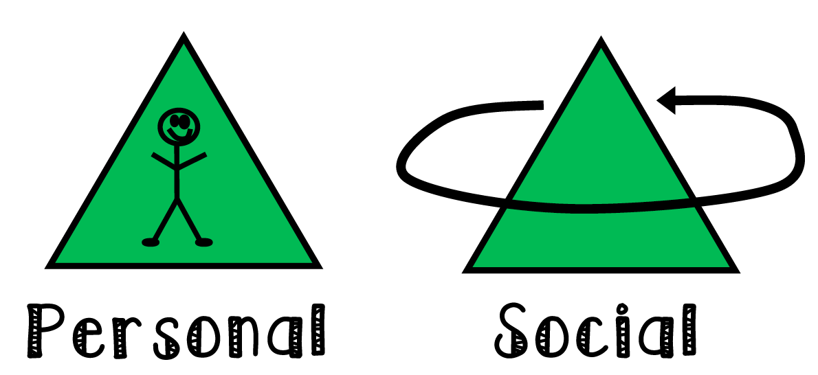
It shows my growing PERSONAL/SOCIAL skills because: _______________________________________________________________________________________________________________________________________________________________________________________________________________________________________________________________
__________________________________________________________________________________
One thing that I would do differently next time is _______________________________________________ because______________________________________________________________________________
__________________________________________________________________________________________________________________________________________________________________________

