Ms. Woods
Science 10
liz.woods@yesnet.yk.ca
In Science 10 it is my aim to introduce you to the patterns and wonders of the natural world and help you appreciate, understand, and analyze them more effectively. Through the processes of inquiry and project-based learning you will engage in meaningful, hands-on science, developing scientific knowledge, skills, and attitudes that will be relevant in your everyday lives and future careers.
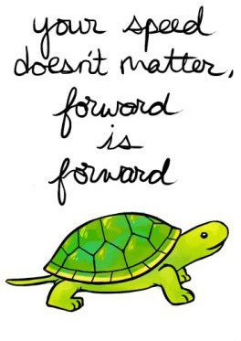
While I am passionate about Science and excited to share that journey with you, I understand that learning is bigger than just the topics we will explore this year. In order to help you become better lifelong learners, and to better prepare you for your learning journey after high school, this course will fully integrate the core competencies to develop skills that can be transferred to any area of your life:
Growth Mindset

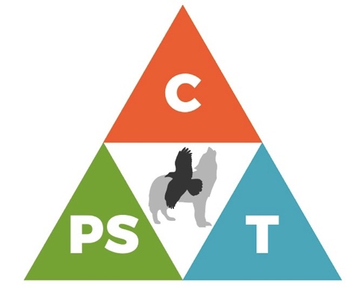
- Communication: I communicate effectively, in well-constructed forms, both verbal and written, that are effective for audience and purpose. I acquire, critically analyze, and integrate information from a range of sources. I ask thought-provoking questions, solve conflicts and challenges, and work well with a team.
- Thinking (Creatively and Critically): I develop creative ideas and works that can be used to solve a problem. I develop ideas that are new, or rework existing ideas into something new. I handle ambiguity, set-backs, and failure, and use them to advance my thinking. I compile and analyze evidence from different perspectives, make well- supported judgments, interpretations and conclusions. I am open-minded and patient, taking the time to explore, discover and understand. I can connect the results of my inquiries and analyses to action.
- Personal Social: I understand my learning is continuous and that I will continue to grow and evolve. I take responsibility for my goals, learning, behaviour and decisions. I use strategies for working toward a healthy and balanced lifestyle. I advocate for my learning needs. I strive to use every opportunity as a chance to improve.
Materials | Attendance | Technology | Communication | Extra Help
Pen, pencil, scientific calculator, ruler, binder, lined paper, graph paper, digital device (optional) | If you are absent, please have a parent/guardian contact the office. | It can be your ally, or a distraction. Please show good judgment and responsible use. | Outside of class, email is the best way to contact me. | Available upon request. Please ask me in class or send me an email to set up a time.
Practical Stuff

Acknowledging, recognizing, and respecting that we are teaching and learning together on the Traditional Territory of the Tr’ondëk Hwëch’in.
Education is not the learning of facts…but the training of the mind to think.
Albert Einstein

Knowing and Understanding

DNA
- What is the structure and function of our genetic code?
- How do genes influence inheritance?
- How do genes influence diversity in the world?

CHEMICAL PROCESSES
- How do atoms rearrange in chemical reactions?
- How are mass and energy conserved in a reaction?
- How are acids and bases used in our daily lives?’
- What practical applications are there for Yukon First Nations traditional knowledge of chemical processes?

ENERGY
- How is energy conserved and transformed?
- What are the local and global impacts of energy transformation?

THE UNIVERSE
- How does the big bang theory explain the formation of the universe?
- What are the components of the universe over time?
- How do we collect and understand data about the universe?
- Questioning and predicting
- Planning and conducting
Doing
- Processing and analyzing data and information
- Evaluating
- Applying and innovating
- Applying Yukon First Nations Ways of Knowing and Doing

Try again. Fail again. Fail Better.
Samuel Beckett

As you have heard, the school is transitioning to a new way of grading called standards-based grading (SBG). SBG focuses solely on your progress towards mastery of the Science 10 learning standards, and provides grades that are accurate, consistent, meaningful, and supportive of learning. Each assessment will provide feedback to you about your strengths, areas for growth, and next steps. SBG reflects your most recent and consistent level of academic achievement, so if you demonstrate that past assessment information no longer accurately reflects your learning, that information will be dropped from grading and replaced by the new information. Non-academic factors such as participation and attendance are not included in your grade. We will discuss the attached FAQs together, so that you will understand SBG and be able to explain this new system to your parents.
Assessment

While not every student in Science 10 plans to pursue a career in science, all of you will become global citizens having to make sound and ethical decisions. This course will help you gain the knowledge, skills, and attitudes needed to make these decisions, and to assess the impact of science and technology on yourself, society, and the environment.
FreshGrade will be used as a portal to dialogue, reflect and track progress in the course. Your parents will be able to view and comment on your progress, should they wish. Email invitations to access this web tool will be send to you and your parents early in the course.

