Prompts for Core Competencies
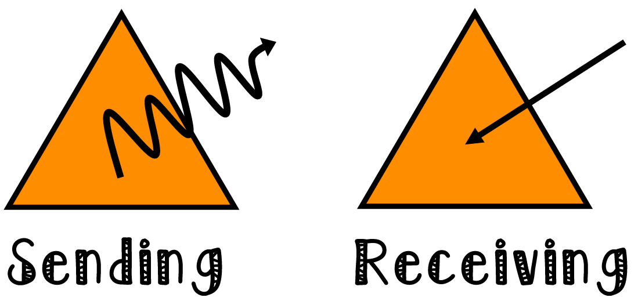
Communication

- How do you share information with others?
- Describe some ways you have collaborated with others.
- How do we communicate effectively? (Looks like, sounds like, feels like).
- How do you show you are an active listener?
- What is my role in group work and how do I connect and engage with others?
- What is your strength in group work?
- What role is easy for you? What role is hard for you?
- How do I acquire/interpret or present information? (focus on one at a time)
- What is the purpose of collaboration?
- Think of a time you presented to others – what worked well? What was important to do?
- Think of a metaphor that shows who you are as a listener, learner, communicator
- What could you do differently?
- Knowing what you know now about…. what would you do differently?
- How did you work with others to develop ideas…to create solutions?
- In what ways did your listening contribute to the groups understanding?
- What do you do when you disagree?
- What strategies do you use to generate ideas?
- What are some strategies you use to present information clearly & in an organized way?
- How do you use the language of discipline to articulate your learning?
- What are some ways you can show your learning?
- Give an example of when you shared information that made your group successful.
- Tell a time when you disagreed with someone and let them know in a respectful manner.
- What kind of feedback helps you learn?
- Tell a time you used feedback to improve your learning.
- What does effective group work look like?
- What strategies do you use to help you present information in an organized manner?

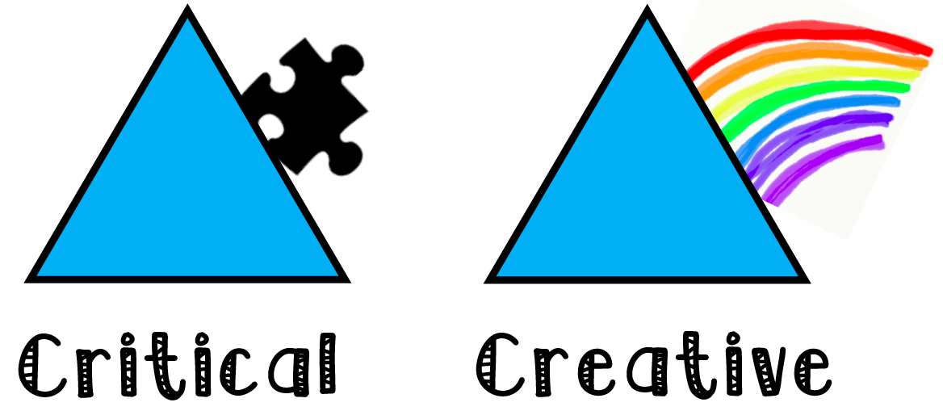
Critical Thinking

- Tell about a time when you had to try more than one strategy to solve a problem.
- What strategy do you use to analyze ideas?
- Can you give an example of…?
- Why do you think…?
- How do you solve….?
- Can you explain…?
- Can you elaborate on the reason…?
- Tell me about a time you used multiple sources to get information? How did you decide if they were real/true/accurate?
- Analyzing: compare and contrast. How are the ideas similar or different?
- Process: The doing – how did you get your “idea”, “solution”?
- What did you see, hear, do to get there?
- Critique: How do you know you were successful? List three words and then describe/brainstorm all of the evidence behind the words.
- Evidence: Needs to be broken down for students.
  - Connections…
  - Reliability…
  - Examples of…
- When/describe a time when you changed your mind and why?
- Describe a time when you used questions to better understand…
- What were you thinking and why?
- Describe a time when you used reasoning and new information to make a decision?
- Describe something that didn’t work and what you did differently?
- What do you think happened when…?
- How did you incorporate other people’s ideas/perspectives?
- Why was this activity so hard? How has your thinking changed? Why?
- What do you think and how do you know?
- What conclusion have you come to?
  - How plausible is….?
  - What evidence do you see….?
  - How did you arrive at your conclusion and where else could you have gone w/it?
  - To what degree...?
  - What are you missing?
  - What questions do you still have?
- How could this be improved?
- What didn’t work and why?
- What’s next?
- How is it going and where to next?
- Can you apply this in another context?
- What choices did you make?

Creative Thinking

- Where do your new ideas come from?
- What do you do with your new ideas?
- Describe a time when you helped build upon the ideas of others.
- Describe the environment that works best for you when creating ideas.
- Describe a time when your ideas took a long time to develop.
- Developing ideas
  - Tell me about and idea in….
  - How have you used other people’s ideas to support your thinking?
- Novelty
  - What personal strategies do you use to generate ideas?
  - How do come up with stuff?
  - What inspires you?

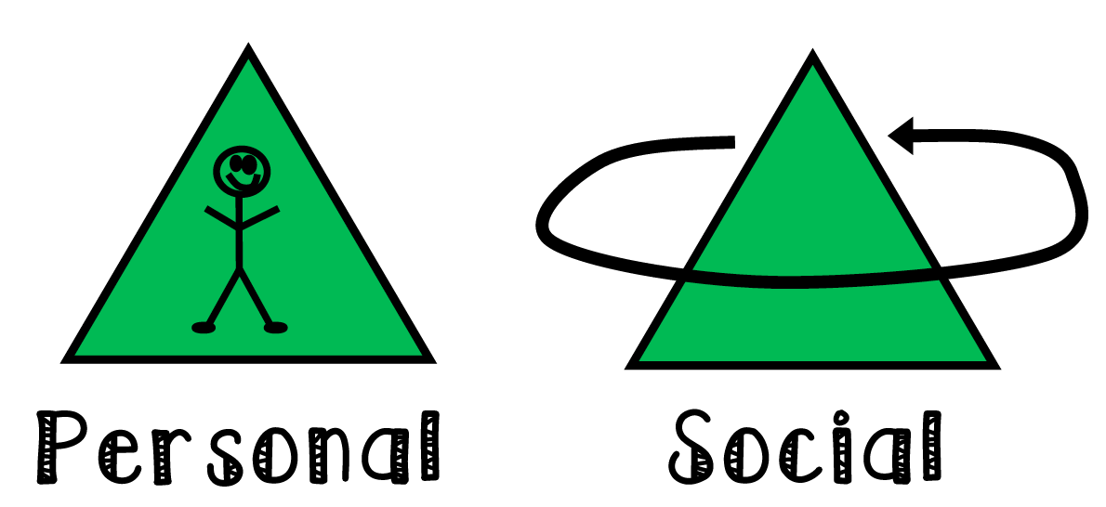
Personal Awareness and Responsibility

- What treasures or gifts do you bring to our class?
- When I am having trouble with something I….
- What storybook characters remind you of yourself?
- What do you need so that you can contribute to our class discussions?
- When I get upset, I….
- I know I am good at this because….
- I keep myself healthy by….
- These events, , helped me to grow by….
- What do I enjoy doing?
- What am I good at?
- What strategies do I use when…?
- What gives me joy?
- What helps you to focus?
- When I am struggling I….
- What strategies do I use to persevere?
- How do you see yourself?
- Tell me about your relationships? (in class/your family/community)
- How do you make choices?
- Give me an example of personal strength (academic or personal)
- I celebrate my efforts and accomplishments by…
- How do I take ownership of feelings and emotions?
- I make healthy choices that positively affect me.
- How do I create my own learning goals and evaluate how I’m doing?

Personal Awareness and Responsibility

- Talk about a time you made sure everyone was included.
- Share something about your community
- Share a time when you used kind questions to learn more about a curiosity you have.
- What does fair look like and how do you make that happen?
- I use kind words and actions to encourage and/or help others.
- I work cooperatively with others in any situation.
- I encourage others to understand the importance of community and/or world events and how they relate to us.
- I look for ways to help make the lives of others better and I take action.
- I plan ways to take care of the environment and I encourage others to join me.

Positive and Personal Cultural Identity

- What makes you unique?
- Tell me about your learning strengths?
- How do you learn best?
- Who are you? I am….
- What makes you sing?
- What is most important to you?
- How do you make good decisions?
- What influences your decisions?

