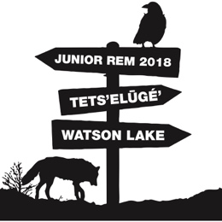
The core competencies are a set of skills and abilities that are the foundation of our new curriculum.
These skills are embedded in every area of learning, including REM.
Please complete this self-assessment by reflecting on your growth in the core competencies during your time at REM.
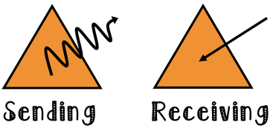  COMMUNICATION | Connect and engage with others (to share and develop ideas)  - I ask and respond to simple, direct questions.  - I am an active listener. I support and encourage the person speaking.  - I recognize that there are different points of view and I disagree respectfully. | Acquire, interpret, and present information  - I understand and share information about a topic that is important to me.  - I present information and ideas to an audience I may not know. |  | Collaborate to plan, carry out, and review constructions and activities  - I work with others to achieve a common goal. I do my share.  - I take on roles and responsibilities in a group. |  | Explain/recount and reflect on experiences and accomplishments  - I give, receive, and act on feedback.  - I recount simple experiences and activities and tell something I learned.
 | Here are some ways that I demonstrated my strengths in COMMUNICATION:
POSITIVE PERSONAL  AND  CULTURAL IDENTITY | Relationships and cultural contexts can describe my family and community.  - I am able to identify the different groups that I belong to.  - I understand that my identity is made up of many interconnected aspects (such as life experiences, family history, heritage, peer groups). |  | Personal values and choices  - I can tell what is important to me.  - I am able to explain what my values are and how they affect choices I make.  - I can tell how some important aspects of my life have influenced my values.  - I understand how my values shape my choices. |  | Personal strengths and abilities  - I can identify my individual characteristics.  - I can describe/express my attributes, characteristics, and skills.  - I reflect on my strengths and identify my potential as a leader in my community.  - I understand I will continue to develop new abilities and strengths to help me meet new challenges.
 | Here are some ways that I demonstrated my strengths in POSITIVE PERSONAL AND CULTURAL IDENTITY:

The core competencies are a set of skills and abilities that are the foundation of our new curriculum.
These skills are embedded in every area of learning, including REM.
Please complete this self-assessment by reflecting on your growth in the core competencies during your time at REM.
PERSONAL AWARENESS  AND  RESPONSIBILITY | Self-determination  - I show a sense of accomplishment and joy.  - I celebrate my efforts and accomplishments.  - I advocate for myself and my ideas. |  | Self-regulation  - I sometimes recognize emotions.  - I use strategies that help me manage my feelings and emotions.  - I persevere with challenging tasks.  - I take ownership of my goals, learning, and behaviour. |  | Well-being  - I participate in activities that support my well-being, and tell/show how they help me.  - I take some responsibility for my physical and emotional well-being.  - I make choices that benefit my well-being and keep me safe.  - I use strategies to find peace in stressful times.  - I sustain a healthy and balanced lifestyle.
 | Here are some ways that I demonstrated my strengths in PERSONAL AWARENESS AND RESPONSIBILITY:
SOCIAL RESPONSIBILITY | Contributing to community and caring for the environment  - With some support, I can be part of a group.  - I participate in group activities that make my world a better place.  - I identify how my actions and the actions of others affect my community and the natural environment and work to make positive change. | Solving problems in peaceful ways  - I solve some problems myself and know when to ask for help..  - I clarify problems or issues, and compromise to meet the needs of others. |  | Valuing diversity  - With some direction, I demonstrate respectful and inclusive behaviour.  - I explain when something is unfair.  - I advocate for others. |  | Building relationships  * With some support, I can be part of a group.  * I am kind to others, work/play co-operatively, and build relationships.  * I identify when others need support and provide it.  * I am aware of how others may feel and take steps to help them feel included.
 | Here are some ways that I demonstrated my strengths in SOCIAL RESPONSIBILITY:

