Building a Learning Map!
Goals

Prior knowledge

Grade Level Curriculum

Course: |  |  |  | Teacher:
Unit Big Idea: |  |  |  | Unit Guiding Question:
 |  |  | 1  Not yet meeting | 2  Approaching | 3  Meeting | 4  Exceeding
Content
Curricular Competencies

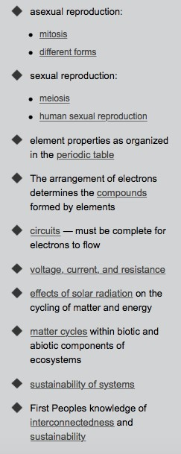
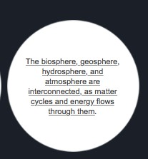

SCIENCE 9
Need to know

Need to understand

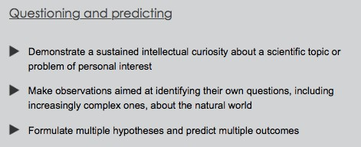
Need do

Course: Science 9 |  |  |  |  | Teacher:
Unit Big Idea: The biosphere, geosphere and atmosphere are interconnected as matter cycles and energy flows through them |  |  |  |  | Unit Guiding Question: Why do we need the sun?
 |  |  | 1 | 2 |  | 3 | 4
Content  Effects of solar radiation on the cycling of matter and energy |  |  | I know that the sun gives light  I know why the Earth needs light from the sun | I know solar radiation  I know the different types of light radiation |  | I know the effects of solar energy on the cycling of matter and energy on the Earth  I know the connection of solar radiation to the water cycle | I know how solar radiation is connected to wind and ocean currents, and the distribution of energy and nutrients around the planet
Curricular Competencies | Questioning and Predicting | Sustained intellectual curiosity | I wonder about a scientific topic | I ask questions about a scientific topic |  | I ask questions to further my inquiry about a scientific topic | I sustain an inquiry about a scientific topic of my own interest over time
 |  | Make observations | I use my senses to observe and describe | I make observations to identify questions about a topic |  | I observe to find patterns to help explain or support a hypothesis | I observe ethically and make connections to phenomena in the natural world connected to my inquiry
 |  | Formulate  Multiple hypotheses | I come up with possible explanations to my wonderings | I make an informed hypothesis about a scientific question |  | I come up with multiple informed hypothesis about a scientific topic | I formulate new hypothesis based on new information in a scientific inquiry  I predict multiple outcomes to my own inquiry

