SYLLABUS: Social Studies 10 (Autumn 2019)
Canadian Politics, History & Society since 1914
Instructor: Sean Wilkinson
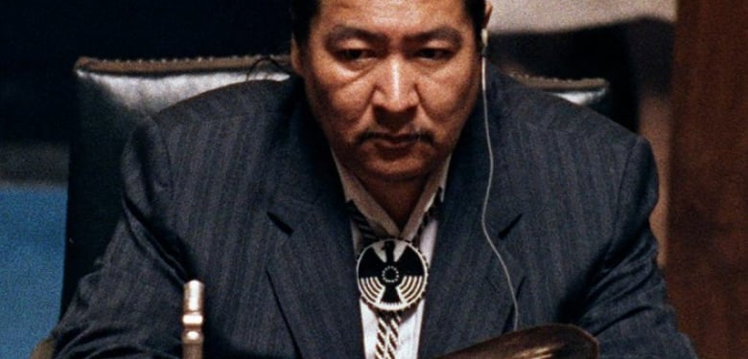

Elijah Harper, 1990, protesting proposed changes to the Canadian constitution that ignored First Nations rights.

Contact Information
Course website: misterwilkinson.com/socials10 E-mail: sean.wilkinson@yesnet.yk.ca
Google Drive: sean.wilkinson.yesnet@gmail.com Phone: 867-332-3206

Objectives & Evaluation: Course Content (Big Ideas)

To receive a passing grade in this course, you must demonstrate understanding of all four big ideas by completing (at a level of “approaching expectations” or higher) a sufficient number of the assignments in each content category.
Canadian government
The development of political institutions is influenced by economic, social, ideological, and geographic factors.
Canadian society
Worldviews lead to different perspectives and ideas about developments in Canadian society.
Human rights
Historical and contemporary injustices challenge the narrative and identity of Canada as an inclusive, multicultural society.
International relations
Global and regional conflicts have been a powerful force in shaping our contemporary world and identities.

Objectives & Evaluation: Curricular Competencies
Your grade for this course will be determined by your demonstration of the curricular competencies (skills) listed below. Each assignment you complete will be linked to one content category and one or more competencies.
Research & Communication
Skill: Use Social Studies inquiry processes and skills to ask questions; gather, interpret, and analyze ideas and data; and communicate findings and decisions
Performance Criteria:
- Your work draws on background knowledge and adequate research of high-quality sources to sensibly answer your research question.
- Evidence is appropriately cited according to the assignment’s format requirements.
- You communicated effectively by meeting the quality requirements of the assignment’s format.
Significance
Skill: Assess the significance of people, places, events, or developments, and compare varying perspectives on their significance at particular times and places, and from group to group
Performance Criteria:
- You evaluate the significance of a historical person or event with explicit reference to notability, impact (breadth, depth, and duration) and revealingness.
- You recognize that significance is subjective.
Evidence
Skill: Assess the justification for competing accounts after investigating points of contention, reliability of sources, and adequacy of evidence, including data
Performance Criteria:
- You demonstrated an understanding of the meanings of the primary sources.
- You situated the primary sources within a reasonable understanding of the historical context.
- You demonstrate “sourcing” skills including analysis of bias, corroboration/contradiction by other sources, and historical accuracy.
Continuity & Change
Skill: Compare and contrast continuities and changes for different groups at particular times and places
Performance Criteria:
- You demonstrate an understanding of what aspects of society, politics, technology, environment, and culture were changed by an event or period, and which remained the same.
- You situate this understanding within a strong grasp of the overall historical context.
Cause & Consequence
Skill: Assess how underlying conditions and the actions of individuals or groups influence events, decisions, or developments, and analyze multiple consequences
Performance Criteria:
- You demonstrate an understanding of how the interplay between historical actors and social, political, economic and cultural conditions results in change.
- You are able to engage in ‘what-if’ thinking.
- You recognize that events have multiple causes that can vary in their influence.
Perspective
Skill: Explain and infer different perspectives on past or present people, places, issues, or events by considering prevailing norms, values, worldviews, and beliefs
Performance Criteria:
- You show an ability to empathize with historical actors.
- You demonstrate an understanding of how a historical actors’ identity (class, race, gender, nationality, political beliefs, etc.) affects their view of historical events and decisions.

Ethical judgment
Skill: Make reasoned ethical judgments about actions in the past and present, and assess appropriate ways to remember and respond
Performance Criteria:
- You answered questions requiring ethical judgment by drawing on explicit ethical criteria.
- You defended your position while acknowledging other possible points of view.
- You provided reasoned evaluations of your classmates’ ethical judgments.

Report Card Schedule & Grade Calculation
Your parents/guardians will receive # explain what they’ll get and when.
On your formal (summative) report card at the end of the course, you will receive a percentage grade based on the Yukon assessment conversion table (see below).
# insert the conversion table

Course Schedule
#
Assignments

You will have multiple chances throughout the course to practice and demonstrate each competency, and your grade for each competency will be based on your most recent, most consistent, and highest levels of performance.To receive a passing mark, you must also demonstrate understanding of each content area (see previous page). A missing assignment does not count as a “zero” but instead as a missed opportunity to demonstrate knowledge.Some assignments (such as tests and seminar presentations) must be completed on a particular day (unless you have an excused absence due to illness or other valid reason). Other assignments (such as essays) may be handed for full marks after the proposed due date.

